**MAJOR EQUIPMENT - University of Wisconsin (UW)**

**UW Radiology MR Equipment**

**Table A:** Available MR scanner facilities at UW-Madison.

*To be installed on 4/18/2018 (RP4) and 6/25/18 (WIMRMR1).

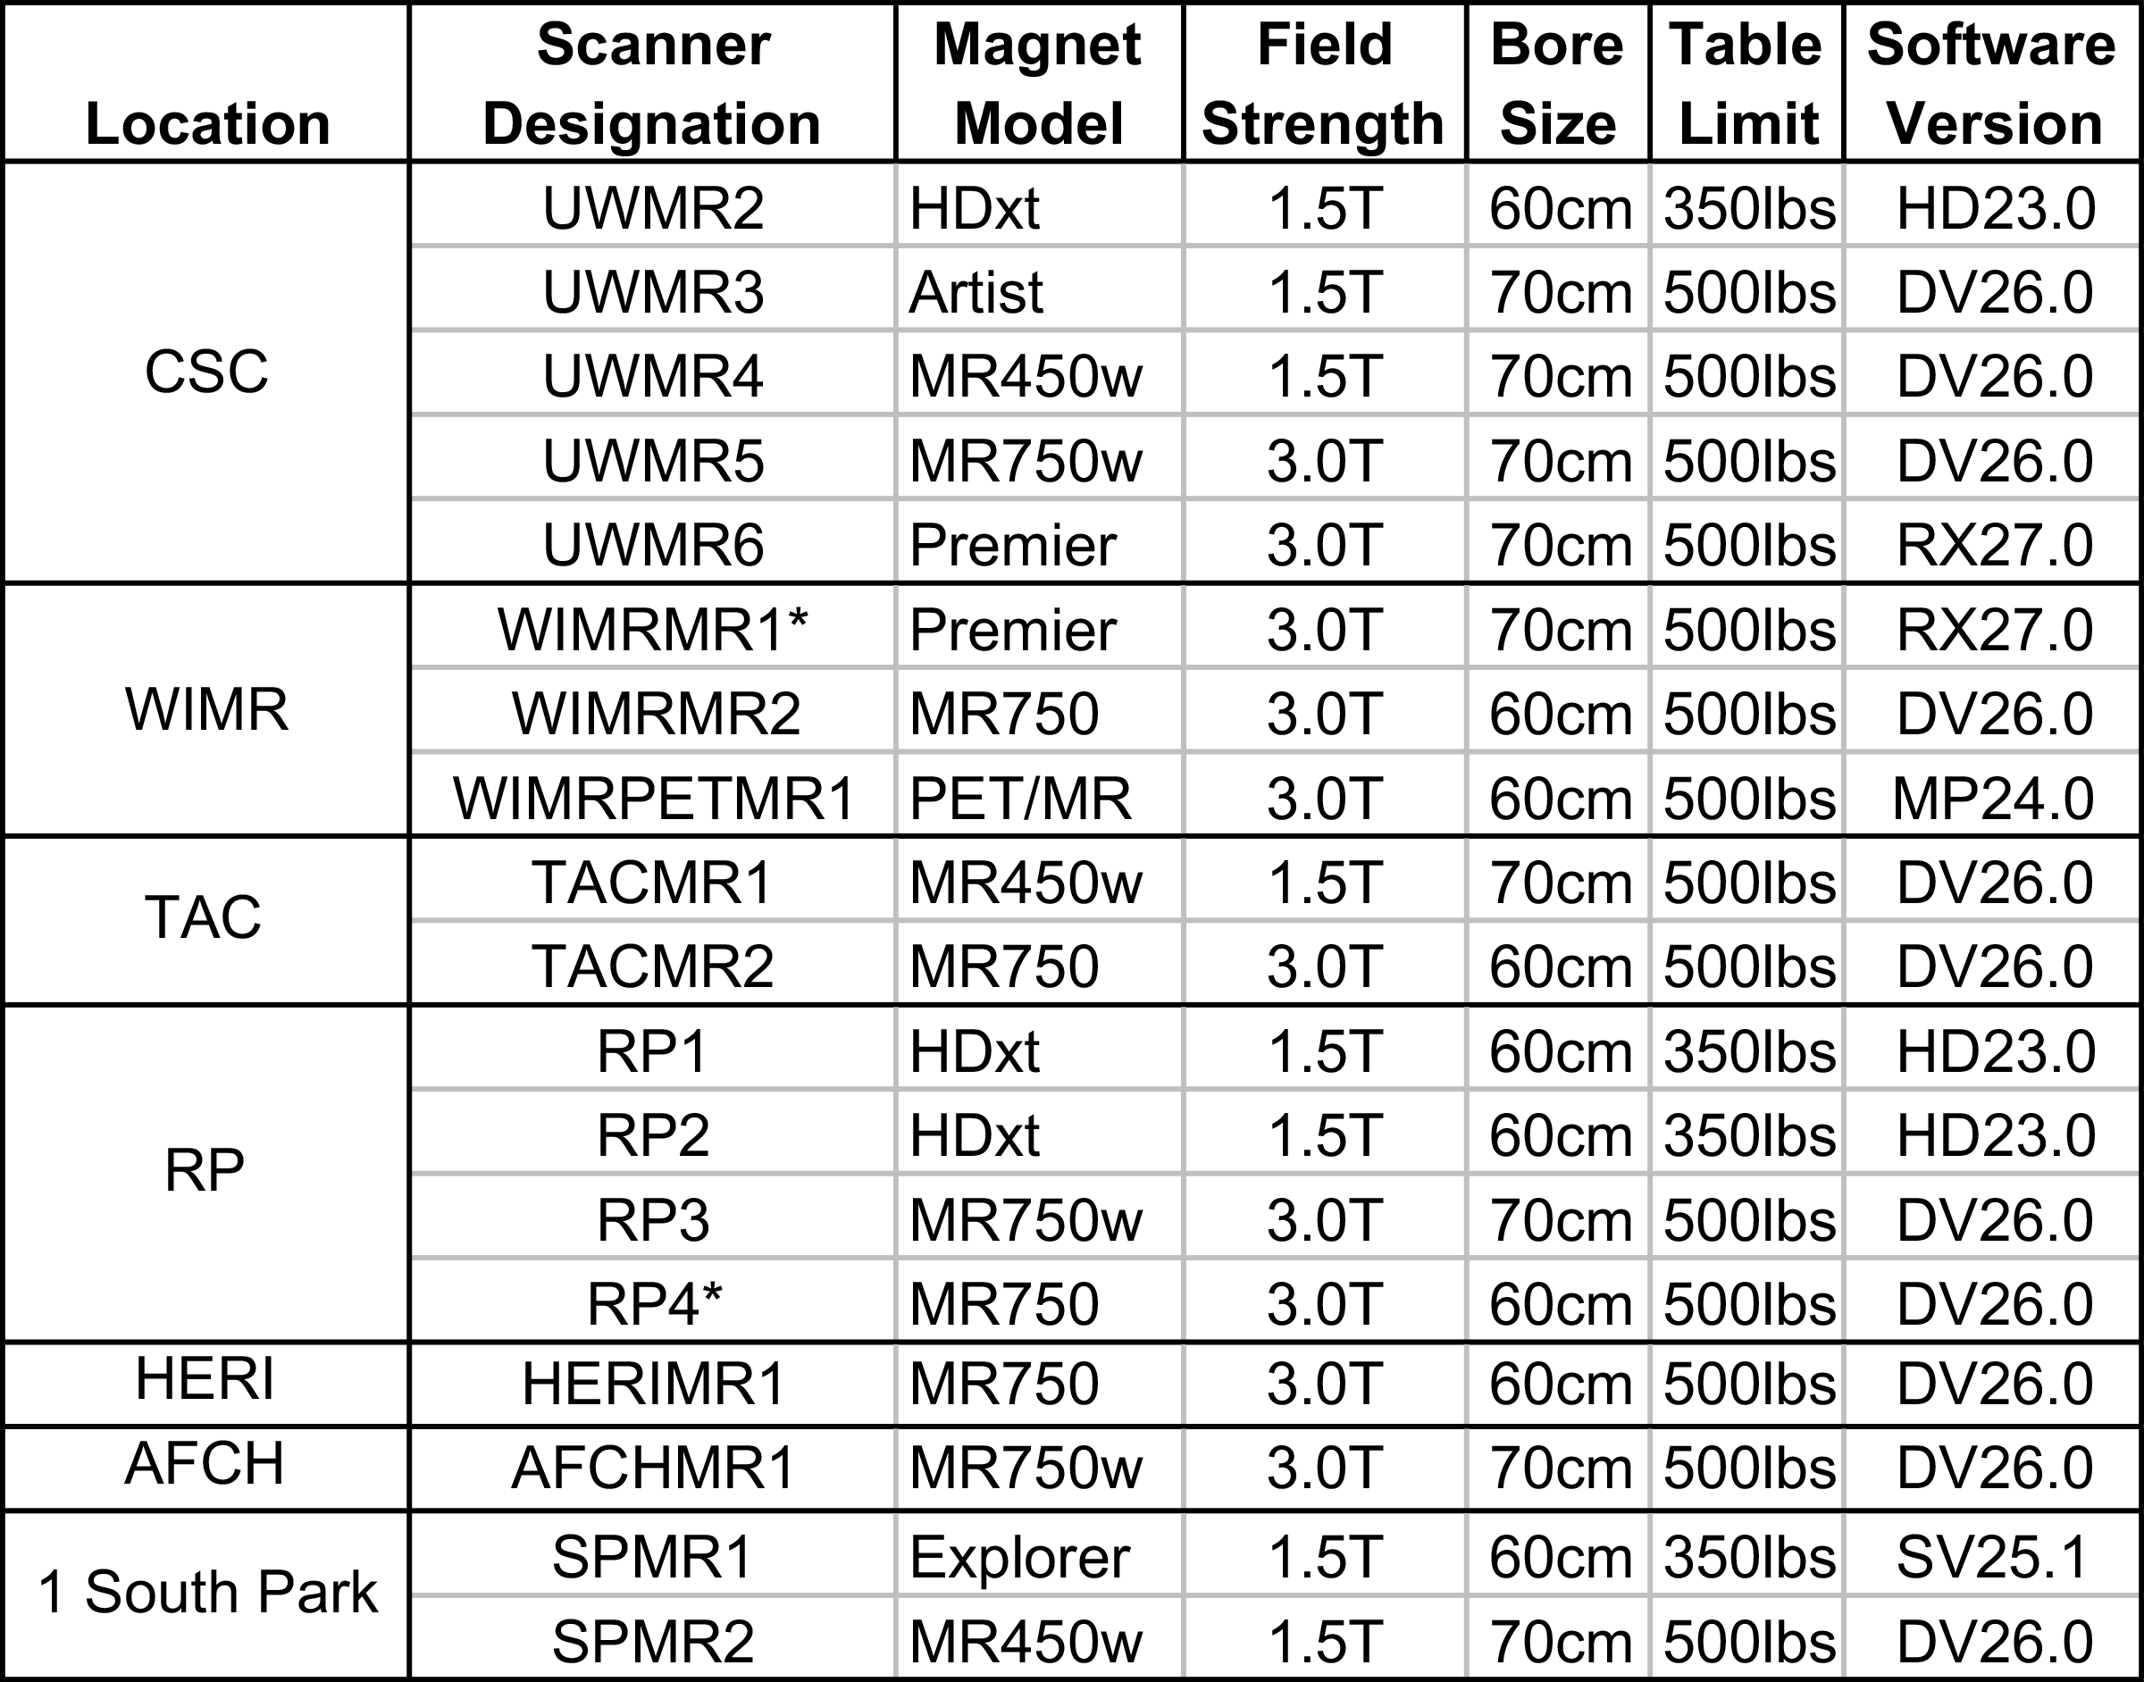

Currently there are 18 clinical MRI scanners (GE Healthcare, Waukesha, WI) in use at the UW Hospitals and Clinics (UWHC) and its satellite facilities, which includes the Clinical Science Center (CSC), Wisconsin Institutes for Medical Research (WIMR), UW Health at The American Center (TAC, a new eastside hospital), as well as outpatient facilities at Research Park (RP), Health Emotions Research Institute (HERI), 1 South Park Street, and the American Family Children’s Hospital (AFCH). The CSC, WIMR and AFCH adjoin each in a single functional complex. HERI, RP and 1 South Park are within three miles of the CSC, and the TAC is a 20-minute drive from the CSC. Details of the systems are listed in **Table A**.

By the beginning of the proposed funding period, there will be five systems (three 1.5T, two 3.0T) located at the CSC, three 3.0T systems located at the WIMR, two systems (one 1.5T, one 3.0T) located at the TAC, four systems (two 1.5T, two 3.0T) at RP, one 3.0T system at HERI, one system at AFCH (3.0T), and two 1.5T systems at 1 South Park. Fourteen of the eighteen systems have 500 lb table limits and eight of the eighteen systems are 70 cm wide-bore magnets (three 1.5T, five 3.0T). Most sites, including TAC and WIMR have wide-bore 70 cm magnets available.

Research is performed primarily on six MR scanners - one of the 1.5T systems in UWHC (UWMR4), two 3.0T systems at UWHC (UWMR5, UWMR6) and the 3.0T scanners (WIMRMR1, WIMRMR2, WIMRPETMR1) in WIMR. Paid research time (with nursing and technologist support) is available for campus users.

Three of the systems (UWMR4, UWMR5 and UWMR6) are shared clinical and research resources and thus have protected time for performing research scans on healthy volunteers and patients during the week and weekends. Scanners at the TAC are also available for research. The three scanners located at the WIMR (WIMRMR1, WIMRMR2, WIMRPETMR1) are installed directly adjacent to the Medical Imaging Group’s office and laboratory space. WIMRMR1 and WIMRMR2 have 100% dedicated research time, and WIMRPETMR1 has 60% research and 40% clinical time.

TACMR1 and UWMR4 are advanced wide-bore 1.5T systems (Optima MR 450w, DV26) with a 70 cm bore. UWMR4 is part of an intraoperative MRI suite, located directly adjacent to a fully equipped operating room. A sliding RF door between the two rooms allows easy transport of patients under anesthesia to and from the operating room for intraoperative MR imaging. WIMRMR1 and UWMR6 are 128-receiver channel GE Signa Premier 3.0T systems, GE’s latest and highest-performing system, with gradient slew rates of 150 mT/m/ms and maximum gradient strengths of 70 mT/m on all three axes, while TACMR2 and WIMRMR2 are 60 cm MR750 systems that provide gradient slew rates up to 200 T/m/s and maximum gradient strength of 50 mT/m on all three axes, with water-cooling for demanding applications with high duty cycles. The other widebore systems have gradient slew rates of 120 T/m/s and a maximum gradient strength of 33 mT/m.

All MRI systems are equipped with a variety of RF receiver coils, including phased-array coils and coils for imaging specific anatomical regions such as the thorax, abdomen, head, neck, spine, and extremities. UWMR4, UWMR6, WIMRMR2 and WIMRPETMR1 each have 32 receiver channels to accommodate multi-channel coils. Each system is equipped with 32-channel phased array body coils for abdominal and cardiovascular imaging. UWMR5 and UWMR6/WIMRMR1 each have 128 and 146 receiver channels, respectively. These systems have patient tables with integrated high-channel count posterior coil arrays, and corresponding anterior coil arrays. In addition, the Signa Premier systems (UWMR6 and WIMRMR1) will soon receive GE’s newest, lightweight, and flexible “AIR” receiver coil arrays for abdominal and cardiac imaging. WIMRMR2 and WIMRPETMR1 are equipped with multinuclear RF capabilities. All systems are connected to independent workstations for off-line viewing and processing.