MAJOR EQUIPMENT
Angiography Equipment

Two x-ray angiography systems in dedicated research labs are available for this project: i) a Siemens Artis Zee bi-plane system in the Interventional X-ray Research Lab, and ii) a Siemens Artis Zee single-plane system in the Large Animal Catheterization Lab. Both labs are fully outfitted for animal and phantom studies, with necessary anesthesia units, medical gases, ventilators, and physiological monitoring systems.

The bi-plane angiography system combines both a floor stand C-arm and a ceiling mounted C-arm to enable simultaneous use of both imaging planes. This system uses two flat panel detectors that have 30cm x 40cm physical dimensions and a native detector resolution of 1920 x 2480 pixels and native pixel size of 154 μm with a bit depth of 14 bits. The single-plane system in the large animal cath lab is a floor-mounted unit with specifications identical to the floor unit of the bi-plane system. The 2D and 3D DSA work in this proposal will be performed with the floor stand C-arm. Each C-arm is equipped with a Megalix Cat Plus x-ray tube and 100 kW generator. These systems have also been equipped with custom x-ray tube control software, provided by Siemens through an existing research contract, that enables frame-by-frame specification of energy (kV), tube current (mA), and pulse width (ms) at up to 60 frame/s. Both x-ray labs provide access to live image data through a vendor-provided workstation and DICOM image data through a Siemens Syngo Workstation.
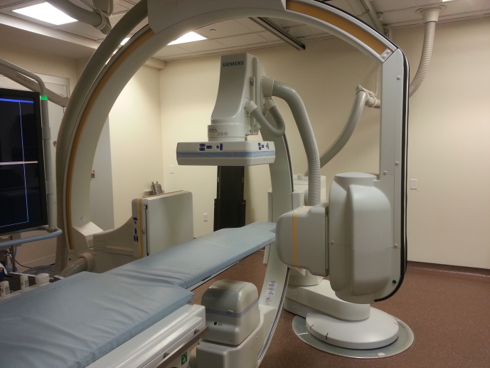
The bi-plane laboratory includes an integrated large-screen display in the operating room that has 56 inch viewing area and a resolution of 3840x2160 pixels. The display accepts 24 different video inputs, and can display up to 9 of these different video inputs simultaneously. Custom image sizes can be configured by using preconfigured layouts to further optimize the in-room image visualization. Prototype images can then be displayed in real time, side-by-side with standard angiographic acquisitions for direct pre-clinical evaluation by the operator.

The academic medical center associated with the University of Wisconsin School of Medicine and Public Health has four state-of-the-art Siemens angiography systems installed in the Departments of Cardiovascular Medicine and Radiology: two Siemens Q.zen bi-plane systems, a Siemens Artis Zee bi-plane system, and a Siemens Artis Zeego multi-axis robotic angiography system. The similarity of these clinical labs to our interventional x-ray research lab will facilitate eventual transition of pre-clinical prototype work to clinical evaluation.

Power Injector

An Accutron HP-D (Med Tron AG) power injector in the pre-clinical angiographic suite described above is available full-time for the projects described in this proposal. It has two injection units which can be controlled independently of each other. It is designed for exact delivery of injections of contrast medium and physiological saline solution. The user can specify delay time of injection, volume of injection, concentration of contrast medium, flow rate and injection time. Up to 60 injection parameter profiles can be stored and then retrieved on demand. Each profile can consist of up to 3 individually programmable injection phases which are then performed automatically after start of the program. The injector has a wireless feature that can communicate with the acquisition program of the Artis Zee angiography system described above.

Phantoms and phantom construction equipment

The following phantoms are available for this work: (1) NEMA SCA&I cardiovascular fluoroscopic benchmark phantom (CIRS Model 901) for Aim 1 image quality studies; includes iodine equivalent contrast detail pattern, resolution gauge, and rotating spoke insert, (2) hollow anthropomorphic chest phantom with ribs and spine embedded in cast acrylic chest wall, for housing the 3D pulmonary arterial tree and lungs in Aim 2, (3) programmable pneumatically-controlled motion stage (Shelley Medical, Inc.) for reproducible phantom motion, (4) programmable flow pump (up to 5 L/min) with pulsatile waveforms, to simulate physiological blood flow through the pulmonary arterial tree, (5) multiple commercial vascular phantoms and self-made phantoms of various vascular territories and pathologies are available including: stenosis models, aortic arch, circle of Willis, aneurysm models. The tubing and phantoms are typically filled with a fluid that mimics the viscosity of blood (Shelly Medical Imaging Technologies, London, Ontario, Canada).

For construction of the pulmonary arterial tree phantom, we have access to a 3D printer which uses a photopolymer resin and SLA (stereolithographic) process. This includes software needed to segment, prepare, and convert a DICOM-formatted 3D CT of a pulmonary arterial tree to the file format used by the printer. We have the necessary equipment for precise fabrication and molding of phantoms from tissue and lung mimicking materials including a custom-built equipment for mixing phantom materials and a rotating stage for curing the phantom. We also have the capability to make molds from 3D printing technology, machined acrylic, and/or traditional hand designed methods using silicone rubber and/or polyurethane plastic (Smooth-on Inc.).
CT scanners

To establish the geometry and material composition of the phantoms, we have a GE Discovery CT750 HD 64-slice CT scanner with both high resolution mode and dual-energy mode. We also have two GE Lightspeed VCT 64-slice cardiac CT scanners that may be used for research; one located in the WIMR building and the other in the UW Hospital.
Animal Study Equipment
We have all of the equipment necessary for large animal surgery. We have ultrasound units for vascular access, 2 anesthesia/ventilator units, and a Vital-Guard 450C portable physiological monitor (Ivy Biomedical, Inc.) capable of ECG, pulse oximetry, end tidal CO2, invasive/noninvasive blood pressure, and temperature monitoring. The monitor has a logic output from an R-peak detection circuit that may be used in real-time ECG-gated or ECG-triggered imaging. We have a portable external/internal defibrillator (Medtronic Life-pak). For the pig studies, we also have catheters and sheaths for vascular access.
Dosimetry equipment

For x-ray exposure measurement we have a Radcal 9010 system with 10X5-6 ionization chamber, Solidose solid-state radiation detector, a PTW N233612 ionization chamber calibrated at diagnostic x-ray energies, a Kiethley parallel-plate ionization chamber, an Exradin Model A6 large-volume (800 cm³) Shonka-Wyckoff spherical air-equivalent ionization chamber for measurement of x-ray scatter, and a Kiethley 6517A electrometer. All exposure meters are regularly calibrated at the UW Accredited Dosimetry and Calibration Laboratory.

