FACILITIES AND OTHER RESOURCES
Scientific Environment: The UW–Madison has a worldwide reputation for graduate training that combines research, interdisciplinary didactic experiences, and practice. Since the early 1980’s, the Department of Medical Physics has been a separate medical school department. It has 28 faculty, 30 academic staff, 7 postdoctoral fellows and approximately 90 graduate students. The department offers a broad range of courses and research opportunities and offers masters and PhD degrees with research opportunities in all areas of diagnostic imaging and radiotherapy. There is a strong and productive relationship between Medical Physics and the clinical departments of Radiology and Cardiovascular Medicine at UW-Madison.

The Department is housed in the Wisconsin Institutes for Medical Research (WIMR). Directly connected to the UW Hospital and Clinics and the UW School of Medicine and Public Health’s “Health Sciences Learning Center” (HSLC), the WIMR and its immediate environment provide state-of-the-art laboratory, classroom, office, and conference room facilities. The physical location of these facilities helps to promote strong interdisciplinary activities by placing Medical Physics faculty and trainees in close proximity with colleagues in Medicine and Radiology. This $134 million facility was occupied in 2008. The Imaging and Radiation Sciences (B1 and L1) floors of the WIMR provide a total of 61,000 square feet of assigned space.

WIMR is designed to allow researchers to work with scientists from other disciplines, speeding the transfer of science to the people who will benefit from it. Currently more than two hundred research studies utilizing WIMR Imaging Services are ongoing. These include both pre-clinical studies and clinical trials using: Positron Emission Tomography (PET), Computed Tomography (CT), Magnetic Resonance Imaging (MRI), Ultrasound, X-ray Angiography, Fluoroscopy, and Ablation technologies. The research proposed in this application will be conducted in WIMR. Longstanding and productive relationships between physicians and scientists in the Departments of Medical Physics, Radiology, Cardiovascular Medicine, and Biomedical Engineering further enhance the environment in which the proposed research will be conducted.

Interventional X-ray Research Lab (Supervisors: Charles Strother, MD and Charles Mistretta, PhD)
Location: A state-of-the-art Siemens Artis Zee bi-plane angiographic system (see Major Equipment) dedicated to animal and phantom studies is located in the WIMR building. It is located close to X-ray, CT, MRI, PET, PET/CT, ultrasound, and other medical imaging systems within the WIMR building and approximately 200 ft. from animal facilities maintained the Research Animals Resource Center (RARC). This lab is a shared resource maintained by the Departments of Radiology and Medical Physics. It will serve as the main imaging platform for this project.

Resources: This x-ray angiographic suite is completely operational and outfitted with necessary supplies, lights, surgical equipment, ventilators, patient monitors, and sterilization equipment. The layout and equipment of the lab are identical to a clinical Artis Zee bi-plane installation. The procedure room houses two C-arms, an x-ray table, a 56” large monitor display, and fixed and mobile leaded shields. The lab has a dual-barrel power injector, physiological monitoring system, and defibrillator. There is a mobile animal mechanical ventilator, wall ports for air, vacuum suction, and oxygen tanks. Both the procedure room and control room have countertop and cabinet space for study prep and storage of equipment. The control room houses control systems and a Syngo 3D workstation.

Veterinarians are on full-time duty to ensure animal health and safety. The University of Wisconsin has adopted the NIH Guide for the Care and Use of Laboratory Animals as its policy and standard for animal care. In addition, the Medical school is accredited by AAALAC. The lab has expert surgical support for a variety of large and small animal models including myocardial infarctions, physiologic monitoring of pressures, ECG, O2, volumes and flows.

Large Animal Catheterization Laboratory (Supervisor: Amish Raval, MD)
Location: The large animal catheterization / surgical prep laboratory is a 2000 sq. ft. facility located on the ground floor of the Clinical Sciences Center, approximately 200 ft. from the Speidel lab and the Interventional X-ray Research Lab. It is directly adjacent to 14 large animal holding rooms, each with the capacity of holding 4 swine if required. The necropsy room is located 20ft away. The facility is also located 3 floors down from the human cardiac catheterization labs, which are accessible through a large service elevator. Animals can be seamlessly received at an adjacent loading dock, housed in the large animal holding rooms, transferred to the large animal cath lab for surgical prep, and then transferred to the Interventional X-ray Research Lab through IACUC approved transfer routes during the day or night.
Resources: This large animal surgical and angiographic suite is completely operational and fitted with necessary supplies, lights, surgical equipment, fluoroscope, ventilators, patient monitors, and sterilization equipment. It has lighting and negative pressure suitable for surgical work, a clinical Siemens Artis Zee single-plane x-ray angiographic system, Medtronic Life-pak external and internal defibrillation unit, and ECG monitoring capability. The cath lab has 3 large 3ft x 6ft x 6ft high catheter cabinet, and multiple shelving units that holds a full complement of surgical tools and catheter equipment similar to an OR or clinical cath lab. There is a gurney and transfer board for seamless transfer of large animals. There is a full-functioning mobile animal mechanical ventilator, wall ports for air, vacuum suction, and oxygen tanks. Gas re-sterilization of surgical equipment and catheters can be performed by our animal techs using hospital equipment in the same building. There are also 3 separate Dell PC workstations in the control room with internet access and software to permit data analysis.
Veterinarians are on full-time duty to ensure animal health and safety. The University of Wisconsin has adopted the NIH Guide for the Care and Use of Laboratory Animals as its policy and standard for animal care. In addition, the Medical school is accredited by AAALAC. The lab has expert surgical support for a variety of large and small animal models including myocardial infarctions, physiologic monitoring of pressures, ECG, O2, volumes and flows.

Speidel Research Lab (Supervisor: Michael Speidel, PhD)
Location: The Speidel Lab is a 660 sq. ft. x-ray suite in the WIMR building, located directly adjacent to the Siemens Artis Zee bi-plane x-ray lab. This lab is equipped for hardware development, phantom construction, x-ray imaging, and animal studies. Currently the Speidel lab houses a prototype low-dose real-time tomosynthesis system (SBDX system) and shared GPU computational resources.
Resources: The procedure room of this lab houses an operational fluoroscopic/angiographic prototype, an x-ray table, medical gases, moveable lead shields, a sink, and an approximately 20 ft. of counter space with upper cabinets and lower drawers for storage of tools, equipment, and supplies for phantom construction. The lab has table position encoders and laser crosshairs to enable reproducible experimental setups. Specialized computational resources include: 10 Nvidia Tesla K20 GPUs configured on a Linux-based real-time reconstruction platform and two high performance Dell workstations with Nvidia GPUs dedicated to image reconstruction, data analysis, and miscellaneous data acquisition tasks. All computers have access to 30TB of networked data storage. The lab also has an auxiliary room for storage of large equipment and phantoms.
Cardiovascular Fluid Dynamics Lab (Supervisor: Alejandro Roldan Alzate, PhD)
Fabrication of the phantom models will be done at the Cardiovascular Fluid Dynamics laboratory, which forms part of the facilities of the Mechanical Engineering Department at UW-Madison, and is well furnished with additive manufacturing machinery including: Ultimaker 2 Extended + (Ultimaker B.V., Geldermalsen, Netherlands): Material Extrusion technology (FDM), Form 2 (Formlabs Inc., Somerville, MA): Vat Photopolymerization technology (SLA) and Laser Sintering Machine (DTM Sinterstation 2500CI ATC with 30 Watt coherent laser and 3 axis M3ST scanning system).

UW Hospital and Clinics: The University of Wisconsin Hospital and Clinics (UWHC) is a 450-bed tertiary care facility that provides access to a full spectrum of patients for clinical research. There are 6 interventional cardiologists, 7 cardiac electrophysiologists and 5 endovascular surgeons, and two interventional nephrologists operating in 8 clinical catheterization laboratories as part of the Cardiovascular service line at the University of Wisconsin Hospital and Clinics and adjoining American Family Children’s Hospital. Approximately 1500 patients undergo structural heart and vascular therapeutic interventions annually, and substantially more undergo diagnostic catheterization. There are three biplane flat panel systems, three hybrid cathlab/operating rooms, and three single plane flat panel systems. Of the biplane labs, two are state-of-the-art Siemens Q.zen systems (Siemens Healthcare, Forchheim, Germany). In addition, the Departments of Radiology and Neurosurgery have a combined cerebrovascular endovascular service with 4 full time physicians who devote their practices to the treatment of patients with cerebrovascular diseases. Between 150 and 200 patients each year are treated with minimally invasive endovascular procedures. These procedures are carried out in a Siemens Artis Zee biplane angiography room.

Shops and Other Labs: Machine shop facilities are available in the Department of Medical Physics for phantom development. The services of the UW Mechatronics lab are available for design and prototyping of the filter wheel device proposed for the dual-energy prototype. The manager of the Mechatronics lab (Erick Oberstar) is a collaborator with Dr. Speidel and Dr. Mistretta. The UW campus has rapid prototyping and 3D printing facilities available for the fabrication of pulmonary angiography phantoms, including software necessary to convert 3D DICOM images to the appropriate file format for 3D printing. The UW Radiation Calibration Laboratory located in the basement of the WIMR building is available for the calibration of ionization chambers and exposure meters.

Computer hardware and software: In addition to the specialized computer resources (see Speidel Lab) all labs in Medical Physics are connected via high-speed (GB) ethernet connections to the campus-wide computer system for Internet access including World Wide Web resources, email, and library resources. Medical Physics has a network of 24 Unix/Linux workstations, ~200 Windows machines, and 15 MACs. There are also two Windows servers and two Unix/Linux servers that serve as file and archive servers (each machine comes with two quad-core CPUs with 2.6GHz clock speed, 16GB of RAM and 32 Terabytes of general purpose storage space) in addition to dedicated and shared 48 TB of space for processing and storage by funded research projects. Each user gets a 275 GB of space for home and data directories on these centralized shared resources that are accessible from user desktop machines and the 10-node computer cluster with (ten 32-core systems with 2.4GHz clock speed and 128 GB of RAM) for image reconstruction, post-processing, analysis. All systems have access to several black & white and color laser printers.

Software on our workstations includes all of the standard UNIX utilities, compilers (C/C++, Fortran, and Java), Emacs, typesetting programs such as LaTeX/TeX, image display programs such as ImageJ, word processors such as OpenOffice, plotting programs such as Xfig, spreadsheet applications, drawing packages, presentation applications, image editing software such as Gimp, and analysis packages such as Matlab and IDL. Software available on the Windows machines includes Microsoft Visual Studio for C/C++/CUDA development, the Matlab technical computing language, Microsoft Office word processing and spreadsheet applications, and image analysis programs such as ImageJ. In addition, all the PCs have X11 server and PCNFS software to permit the Unix workstations and disks to be accessed from the PCs. All Unix software is accessible from all workstations (unless prohibited by the software license agreement).

Office: The PI, Co-Investigators, and graduate students have offices in the WIMR and UW Hospital that are in close proximity to each other and to the laboratories listed above.
Other: All UW faculty and staff members have access to UW support services including University Stores and Purchasing Departments, the Safety Department, Radiation and Biological Safety, Animal Use, and Human Subjects committees. Other support services available on a fee-for-service basis include electronics and machine shops, medical illustration and photography services, and computer support. Each member has physical and electronic access to the excellent library facilities located at several locations on campus. All are totally Ethernet-connected, allowing direct, high-speed access, for example, to more than 16 electronic databases including Medline, Cancerlit, and Science Citation Index.

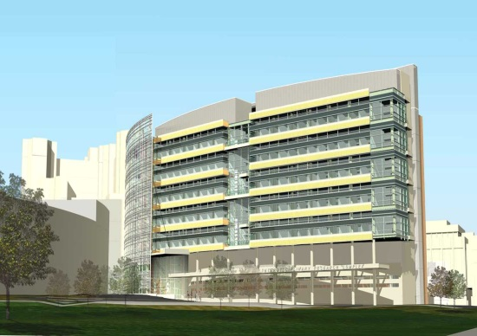 | 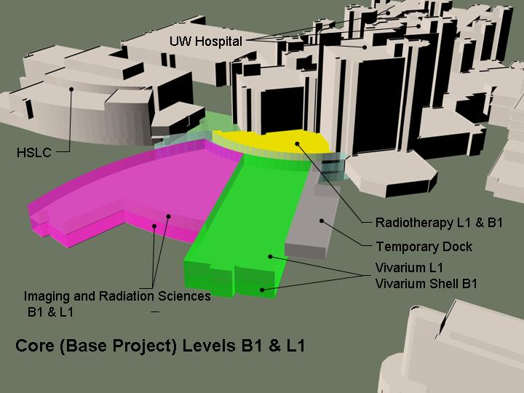
Left: Elevation view of the Wisconsin Institutes of Medical Research (WIMR). The UW Hospital is to the rear of the WIMR and the Health Sciences Learning Center (HSLC) is to the left.
Right: Plan view showing the B1 and L1 levels of the WIMR. The relationships between the WIMR, the HSLC, the vivarium, and the UW Hospitals are depicted.

